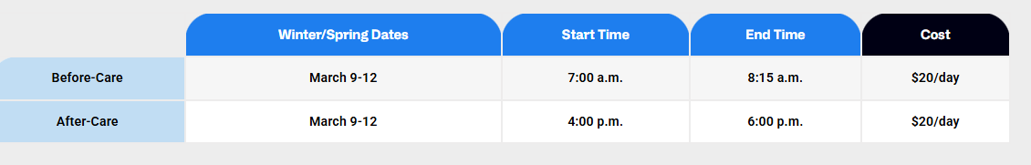

Change: Summer Date
Before-Care May 26-29-August 3-7
After-care May 26-29-August 3-7

